**Understanding the Second part into Compiler Design**

Andres Choque

Liberty University: School of Business

CSCN 434: Compiler Design - AST and IR (LLVM)

November 20, 2022

**Understanding the Second part into Compiler Design**

**Screenshots of the functionalities**

1. **Division**

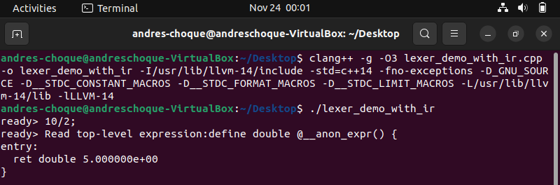

**Figure 1.1** displays 10/2

1. **Logical or**

**Figure 1.2** displays x | y

1. **Logical and**

**Figure 1.3** displays x&y

1. **Logical exclusive or**

**Figure 1.4** displays x^y

**Full picture:**

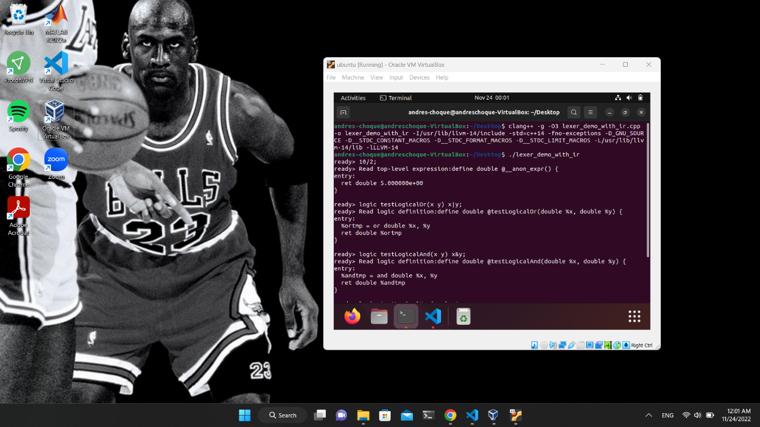

**Figure 2.1**